Step-by-step Instructions on Using the Fping Tool
Original written by Tanvir Rahman Taiyeb
Reviewed and updated by Robin Fosberry

Introduction
This comprehensive step-by-step guide will teach you how to use the Fping tool for fast and effective network host discovery. By the end of this guide, you'll be able to configure and execute custom ICMP ping sweeps across single IPs, ranges, or subnets to identify responsive hosts using the Deakin Detonator Toolkit (PT-GUI).
⚠️ Warning: Only use Fping on networks you own or have explicit permission to scan. Unauthorized scanning can lead to legal consequences.
Step 1:
Open Terminal in your Kali Linux.
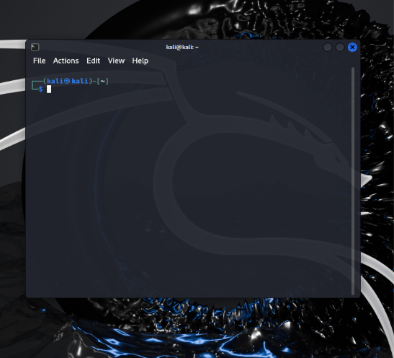
Figure 1: Terminal opened in Kali Linux.

Step 2:
Navigate to where you have placed the “Deakin Detonator Toolkit” directory using the cd command, for example: “cd Deakin-Detonator-Toolkit”.
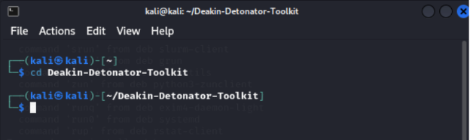
Figure 2: Navigating to the Deakin Detonator Toolkit directory.
Step 3:
Start the Toolkit by running: “yarn run tauri dev”
Tip: If Yarn isn’t installed yet, run npm install -g yarn first.
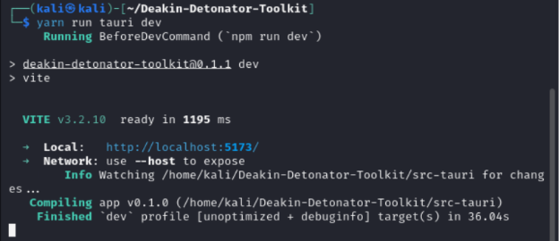
Figure 3: Starting the Toolkit using yarn run tauri dev command.

Step 4:
Navigate to the Fping tool.
From the PT-GUI interface, find the Fping tool in the tool list or use the search bar to quickly locate it, then click Go.
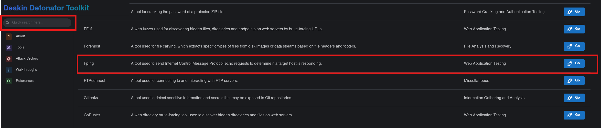
Figure 4: Accessing the Fping tool from the PT-GUI interface.

Step 5:
Access the “User Guide” tab.
Read the built-in user guide inside the tool to get a basic overview and usage examples for Fping.
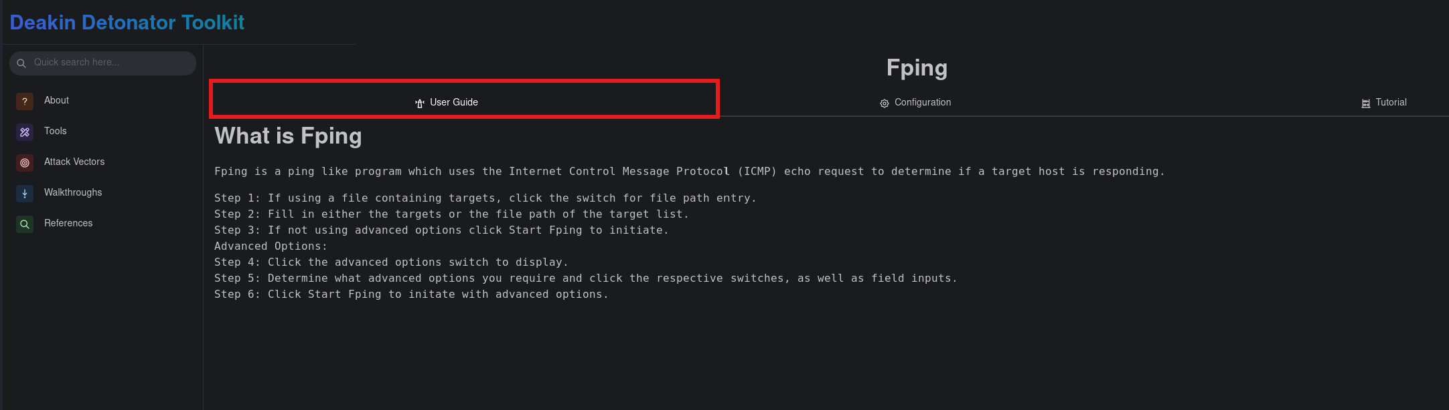
Figure 5: Viewing the Fping User Guide tab.

Step 6:
Configure Your Scan.
Navigate to the “Configuration” tab to customize how your Fping scan behaves.
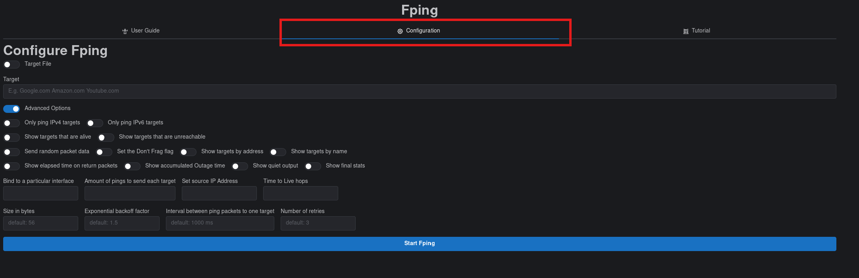
Figure 6: Accessing the Fping Configuration tab.
Step 7:
Configuration Table
The following configuration table provides a clear explanation of each option available in the Fping tool configuration panel inside the Deakin Detonator Toolkit (PT-GUI). Use this table to correctly set up your scans without confusion.
Configuration Option | Example Inputs | Description
Target | example.com, 10.0.2.0/24, 192.168.1.1-192.168.1.50 | Enter single host, range of hosts, or subnet to ping.
Target File | /home/kali/Desktop/hosts.txt | Enable this option allows us to read target hosts from a file (one per line).
Only ping IPv4 targets | Enabled / Disabled | If enabled, only IPv4 targets will be pinged.
Only ping IPv6 targets | Enabled / Disabled | If enabled, only IPv6 targets will be pinged.
Show targets that are alive | Enabled / Disabled | Show only hosts that respond to pings.
Show targets that are unreachable | Enabled / Disabled | Show only hosts that do not respond.
Send random packet data | Enabled / Disabled | Fills ping packets with random data instead of zeros.
Set the Don't Frag flag | Enabled / Disabled | Set the 'Don't Fragment' bit in the packet.
Show targets by address | Enabled / Disabled | Show targets' IP addresses in the output.
Show targets by name | Enabled / Disabled | Show hostnames of targets in the output.
Show elapsed time on return packets | Enabled / Disabled | Display time taken by each ping response.
Show accumulated Outage time | Enabled / Disabled | Show total outage time if a host was unreachable.
Show quiet output | Enabled / Disabled | Minimize the output to reduce noise.
Show final stats | Enabled / Disabled | Show summary statistics after the scan completes.
Bind to a particular interface | eth0, wlan0 | Specify a network interface to use for sending pings.
Amount of pings to send each target | 1, 3, 5 | Number of ping requests sent to each host.
Set source IP Address | 192.168.1.100 | Set a specific source IP address for sending pings.
Time to Live hops | 64, 128 | Set maximum number of hops for packets.
Size in bytes | 56, 100, 512 | Size of each ping packet (default is 56 bytes).
Exponential backoff factor | 1.5, 2.0 | Controls delay increase between retries.
Interval between ping packets to one target | 500ms, 1000ms | Time interval between sending pings to the same host.
Number of retries | 1, 2, 3 | Number of retry attempts per host if no reply.

Step 8:
Start the Scan.
Click the “Start Fping” button once you’ve set your target and desired configurations.
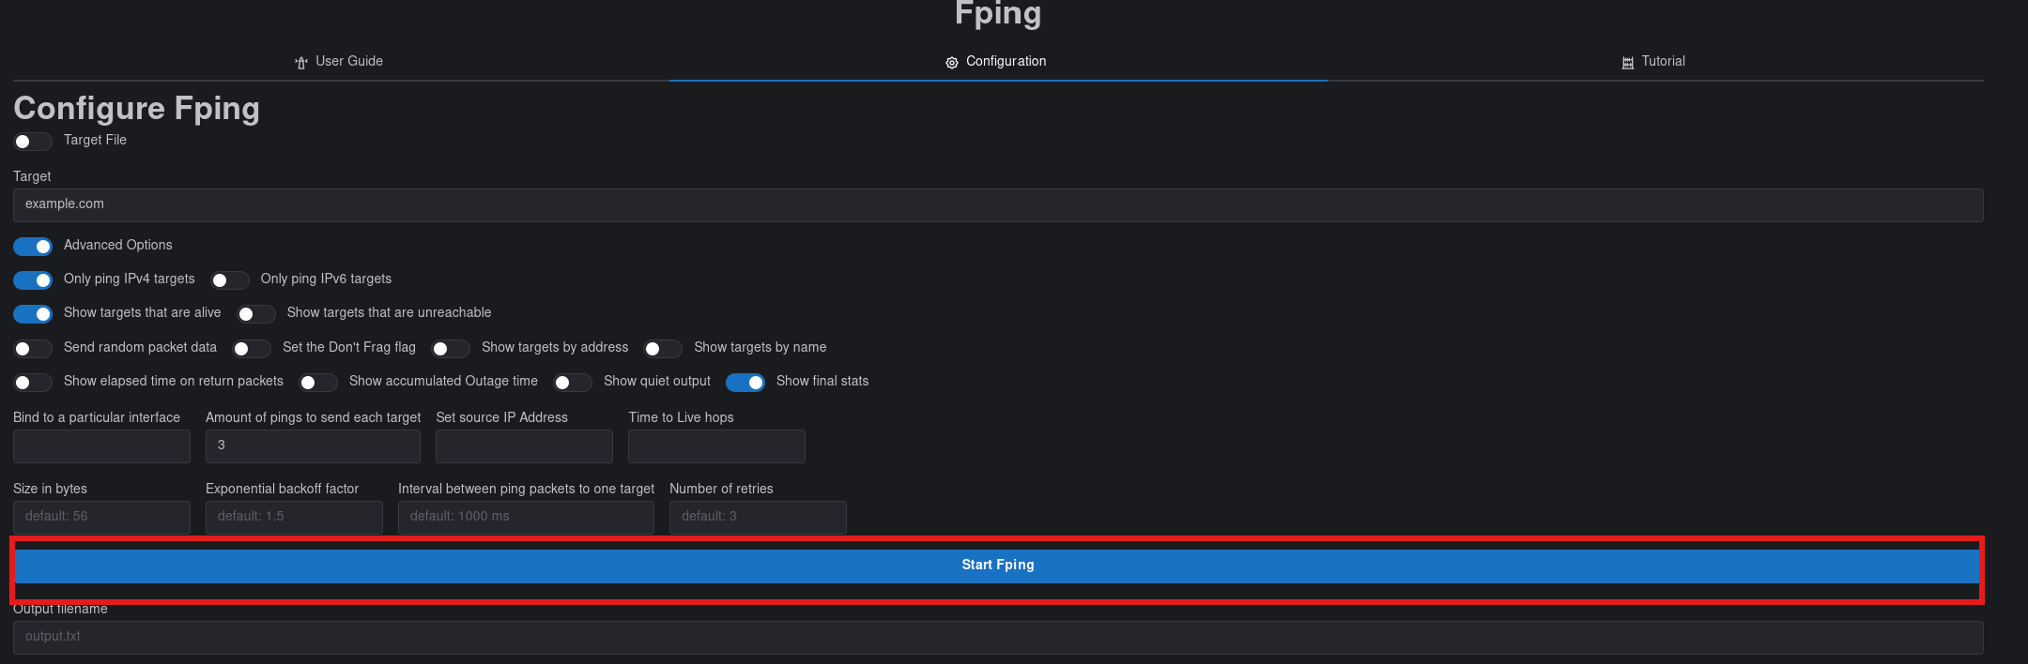
Figure 7: Running the Fping scan by clicking the Start Fping button.

Step 9:
View the Output.
Observe the real-time results in the console output window at the bottom of the application. This will show which hosts responded, round-trip times, and other stats depending on your settings.
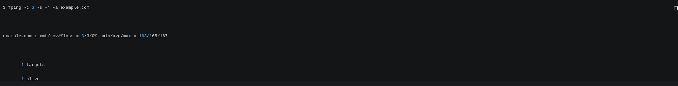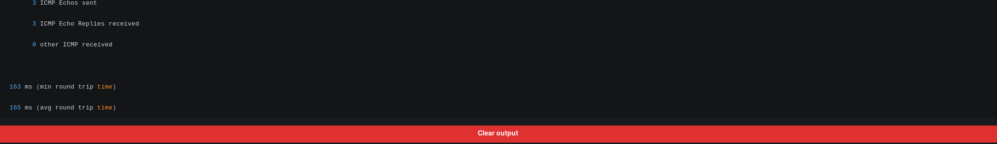
Figure 8: Viewing the real-time scan output showing live hosts and ping response times.
Example Output Explanation:
Fping -c 3 -s -4 -a example.com: (-c 3) send 3 pings to target, (-s) after pings finish, print a summary of results, (-4) force only IPv4, (-a) show only live responses.
example.com : xmt/rcv/%loss = 3/3/0%, min/avg/max = 163/165/167: (xmt/rcv/%loss = 3/3/0%) 3 packets sent, 3 received, 0% packet loss, (min/avg/max = 163/165/167) minimum round-trip time 163 ms, average 165 ms, maximum 167 ms.
1 targets: number of hosts tested was 1,
1 alive: 1 host responded and is alive,
3 ICMP Echos sent: 3 ping requests were sent,
3 ICMP Echo Replies received: all 3 requests were answered,
0 other ICMP received: no unexpected ICMP packets were received.
Step 10 (Optional):
Save the Output to a File.
Enter a file name and click “Save Output to File” to save your scan results for future analysis or documentation.
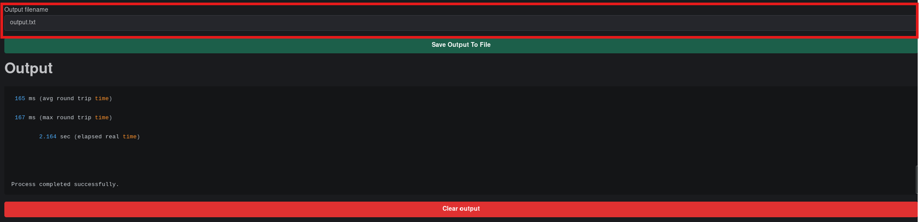
Figure 9: Saving the scan output to a file for documentation.

Conclusion
In this guide, you’ve learned how to use the Fping tool within the Deakin Detonator Toolkit to perform lightning-fast ICMP ping sweeps across networks. With a highly customizable interface and real-time output, Fping is perfect for identifying live hosts prior to further scanning or enumeration. Always scan responsibly and within the scope of your authorization.

